

FACULTY OF SCIENCE AND TECHNOLOGY

MIT725 DATA WAREHOUSING AND DATA MINING
AUGUST-DECEMBER 2026 CONTINUOUS ASSESSMENT TEST ONE (CAT1)

Student’s Name: Emmanuel D.R. Yardanmah
Student_ID: 280-080

Question 1:
Clean the dataset to avoid noise and upload it to your GitHub Data Warehouse. ( 5 marks).
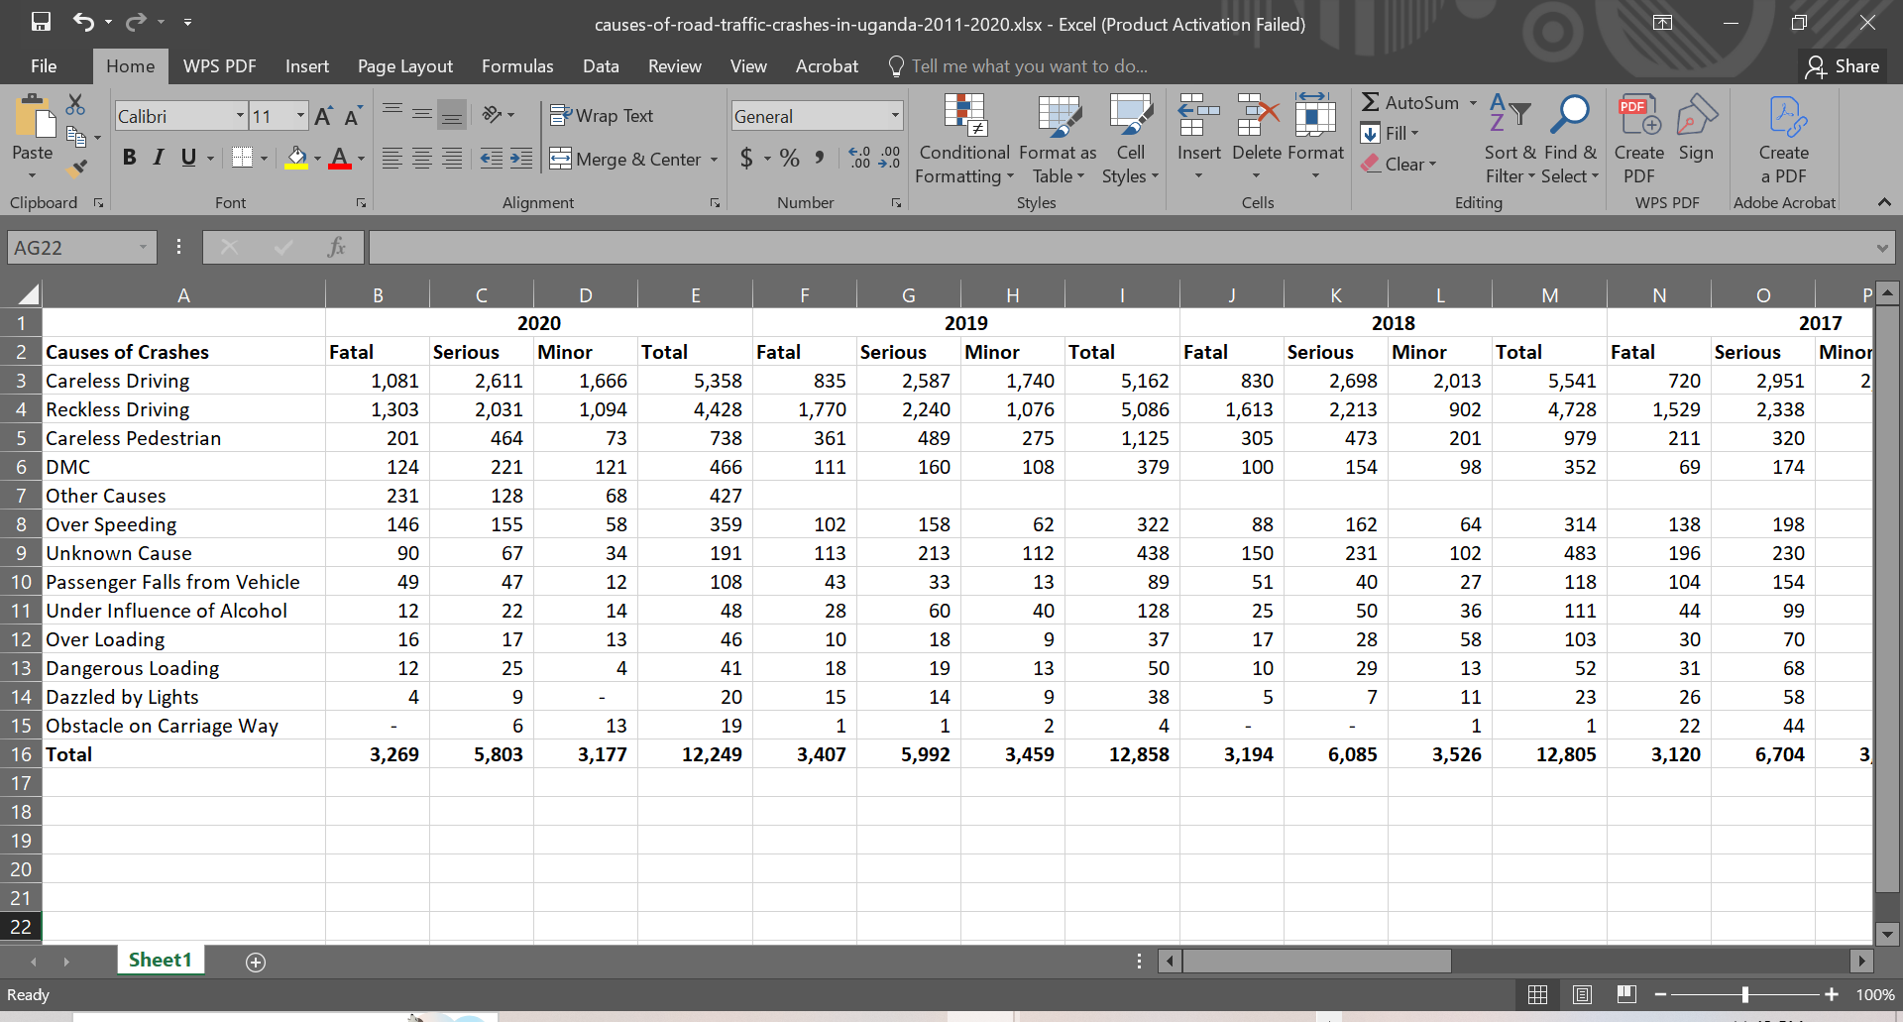
Dirty_Data_Set

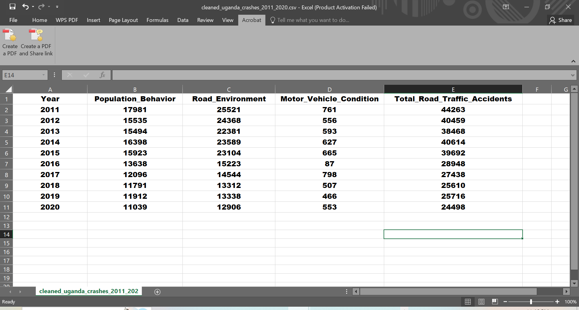
The Cleaned Data Set

Question 2:
Import the file into your Python environment from your GitHub for analysis and produce a heatmap showing the relationship among variables: Population_Behavior, Road_Environment, Motor_Vehicle_Condition, and Total Road Traffic Accidents. (10 marks)

I) Cleaned Dataset Saved to my GitHub Account

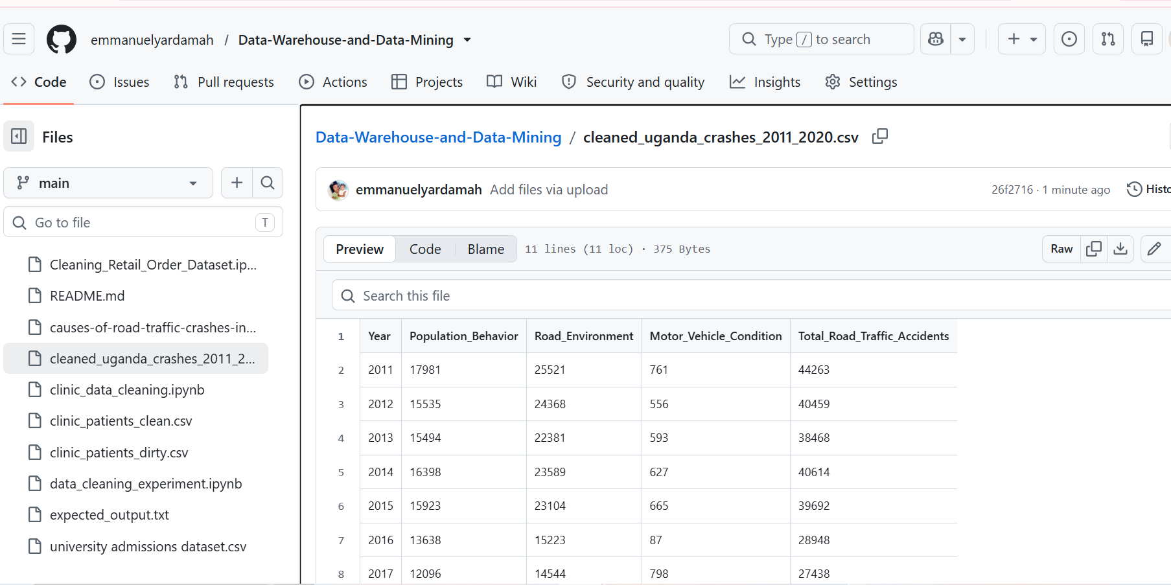

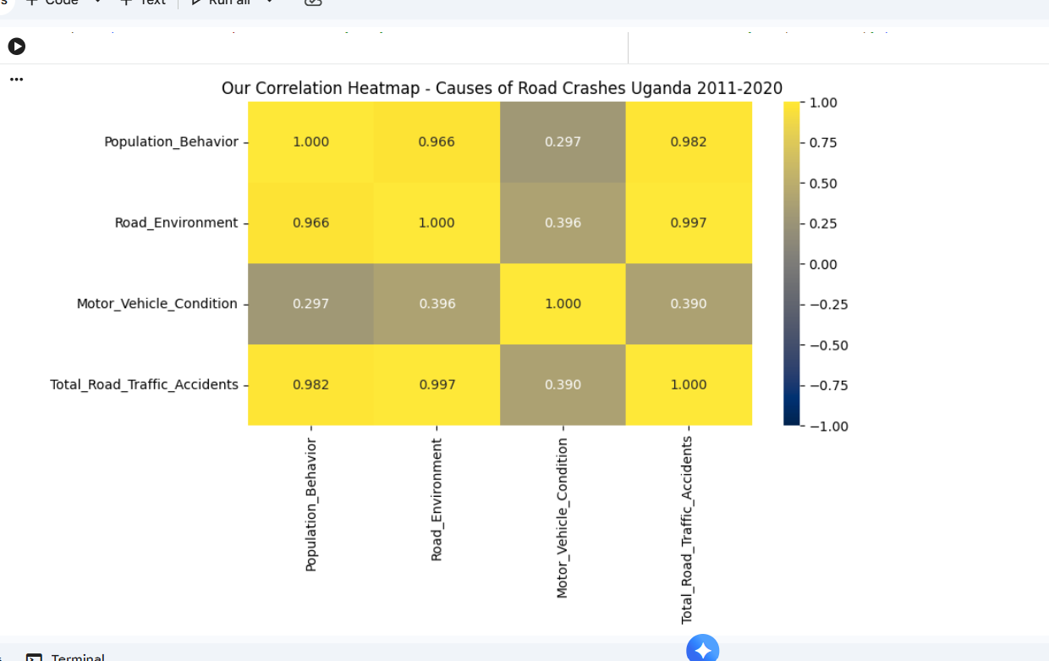
II) Heatmap showing the relationship among variables: Population_Behavior, Road_Environment, Motor_Vehicle_Condition, and Total Road Traffic Accidents.

Interpretation of the Heatmap
After writing my code, I noticed that the heatmap is a correlation matrix showing the Pearson correlation coefficient (r) between four annual variables for 2011–2020 (ten observations): Population_Behavior, Road_Environment, Motor_Vehicle_Condition and Total_Road_Traffic_Accidents. Each cell takes a value from −1 to +1. The closer to +1, the more strongly two variables rise and fall together. In this plot, bright yellow cells mean a strong positive relationship and grey-brown cells mean a weak one. The diagonal is 1.000 because each variable is perfectly correlated with itself, and the matrix is symmetric, so there are six unique relationships:

Variable pair | r | Strength
Road_Environment – Total Accidents | 0.997 | Near-perfect positive
Population_Behavior – Total Accidents | 0.982 | Very strong positive
Population_Behavior – Road_Environment | 0.966 | Very strong positive
Motor_Vehicle_Condition – Road_Environment | 0.396 | Weak positive
Motor_Vehicle_Condition – Total Accidents | 0.390 | Weak positive
Motor_Vehicle_Condition – Population_Behavior | 0.297 | Weak positive

Question 3:
Write a one- to two-page report of your findings. (5 marks)
I. Data Cleaning Process
During the cleaning process, I noticed that the raw excel file was in a wide, report-style layout. Years were merged header cells, each year was split into Fatal, Serious, Minor and Total columns, some cells were blank or held a dash instead of a number, and the 13 detailed causes of crashes were listed as rows. This structure is unsuitable for analysis, so I cleaned it in Python (Google Colab) as follows:
- I loaded without a header and forward-filled the year row, so every column knew its year. The year and severity rows were then combined into unique column names such as 2020_Fatal.
- I renamed the first column Causes_of_Crashes and removed the two header rows.
- I converted all values to numbers using to_numeric(errors='coerce'). Blanks and dashes were replaced with 0.
- I identified the annual Total columns for each year.
- I grouped the detailed causes into three factors using keyword rules. Population_Behavior covers careless and reckless driving, pedestrians, speeding, passenger falls and alcohol. Motor_Vehicle_Condition covers DMC and over or dangerous loading. Road_Environment covers all remaining causes (other, unknown, dazzled by lights, obstacles).
- And I aggregated by year into a tidy table of 10 rows and 5 columns (Year plus the four variables). This was saved as CSV/XLSX, uploaded to GitHub and re-imported into Python for the heatmap.
Data-quality issue found during verification: the spreadsheet's own "Total" row was not removed before step 5. It matched no keyword, so it fell into the default Road_Environment category and was counted twice. For example, the 2020 total of 24,498 is exactly twice the true 12,249. Excluding that row would give Road_Environment values of roughly 657 (2020) instead of 12,906, and the corrected correlations would be Behavior–Environment 0.901 and Environment–Total 0.964. The other coefficients stay essentially the same (0.297 and 0.390; 0.402 for Vehicle–Environment). The conclusions below therefore hold, but the Road_Environment figures are overstated, and the cleaning script should drop the Total row before categorizing.

II. Heatmap Analysis
Strong relationships. Population_Behavior and Road_Environment are both very strongly correlated with total accidents (0.982 and 0.997), and with each other (0.966). Part of this is built in, because the total is the sum of its components. The main reason, however, is the shared downward trend: total crashes fell from 44,263 in 2011 to 24,498 in 2020 (about −45%), with behaviour-related crashes down about 39% and environment-related crashes down about 49%, including a sharp drop in 2016. Variables that fall together over time correlate strongly, but this does not prove that one causes the other.
Weak relationship. Motor_Vehicle_Condition has only weak correlations (0.297 to 0.396). It is a small share of crashes, around 2% of the 2020 total, and it behaves erratically. It dropped to 87 in 2016 and then rose to 798 in 2017, so it did not follow the national decline.
Practical meaning. Human behaviour is the largest identifiable cause. In 2020, careless driving (5,358) and reckless driving (4,428) alone exceeded all other causes combined except the grouped total. Interventions should therefore prioritise enforcement, speed control and driver and pedestrian education. Vehicle inspection remains important for safety, but it is unlikely to move the national totals much.
Limitations. Only ten annual observations were used, so the coefficients are unstable. The keyword-based grouping is a judgement call, and the double-counted Total row (Section 2) inflates the Road_Environment values.
III. Conclusion
The cleaned data show that road crashes in Uganda declined steadily over 2011–2020. Population behaviour and the road environment move closely with the total, while vehicle condition is weakly related. After the Total-row correction, the findings remain consistent: driver and pedestrian behaviour should be the main target of road-safety policy.

